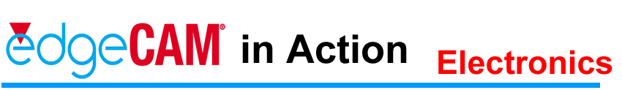

Haverhill Proves 3-D Machining Future With EdgeCAM

One of the concerns always facing Suffolk-based Haverhill Mould and Tooling in its manufacture of plastic mould tooling, press tools, blow moulding and die casting tooling was the risk of gouging the machined or adjacent surfaces with the cutting tool while 3-D machining. "That can ruin a very expensive component," insists Nigel Farenden, managing director.
However, following the installation of EdgeCAM software from Pathtrace Nigel Farenden maintains life is a lot easier and any previous concern or problems associated with gouging have disappeared. "With EdgeCAM we can totally rely on any code generated," he said.
The Suffolk-based precision engineering company largely specializes in concept-to-completion projects. To that end, it has a well-equipped machine shop with CNC machining and EDM sinking facilities, capable of manufacturing tooling weighing up to three tonnes.
The company has its own try-out/pre-production and production moulding shop with plastic injection moulding machines having up to 330 tonnes locking force. In addition, Neil Farenden sometimes has to provide CNC program development for third party companies.
He comments: "We've used Pathtrace's off-line programming for some time. We started with a PAMS system and have religiously upgraded to take maximum advantage of any new developments. As a result, we know the system very well.

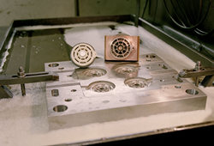
Visual Enhancements
The latest version of EdgeCAM is far superior to anything that went before in terms of its capability to position and visualise a 3-D model. We can also take in SolidWorks generated 3-D models without using a translator."
He describes: "With EdgeCAM we now have total flexibility to totally check the whole part on-screen and through the browser at the side of the screen, we can add descriptive names to each layer. If we need to adjust or amend the program, it is so easy when you know exactly where to start."
A high proportion of Haverhill's tool work is related to optical moulding for vehicle lighting systems and commercial lighting applications. This is very demanding with tolerances having to be maintained within 0.012 mm. Equally, many of the other applications require development of complex tools incorporating sliding cores or are based on modular formats which enable a variety of components to be moulded from one basic tool 'kit'.

Complex Parts
Turnaround time on injection mould tools, which tend to be fairly complex, is kept to an average of six weeks by developing the tooling and CNC programming in parallel with the manufacturing process. The normal method of mould cavity production is to machine as much as possible on the company's CNC mills and machining centre, then finish the cavity using vertical EDM to produce features such as sharp internal corners that cannot be finished with a milling cutter.
Neil Farenden explains how they hardly produce any two dimensional moulds. "Most comprise complex surface geometry involving quite a lot of tool design or product redesign before we can set about making the actual tool," he says.
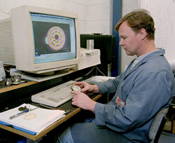
Because so much of the company's work involves redesign, Neil Farenden maintains: "It must only be half a dozen or so times a year when we get jobs where we can work straight from the client's model. More often than not, we have to redefine split lines and rework the component geometry to make the moulding process practical and efficient. In its latest form, EdgeCAM's excellent model import and rendering facilities really do improve this part of the process," he insists.
Neil Farenden outlines that with EdgeCAM, he has the capability to break a component up into discrete surfaces giving benefits such as better surface trimming. Moreover, machining strategies, such as providing the choice of infeed approach, are important and the advanced machining capabilities mean it is easy to dictate a consistent finish on both sloping and flat surfaces. In addition, the Z-level finishing capability is seen as being especially effective.
Once a machining program is developed in EdgeCAM the data is downloaded via DNC and drip fed when the programs are larger than the available memory space on the machine tool control. In particular, the EdgeCAM Code Wizard post processing system provides the opportunity to make use of resident control features such as rotation and repetition. "This allows complicated forms to be machined using relatively short programs, which also means we have the benefit of running much faster," Neil Farenden says.
Code Wizard
Haverhill makes considerable use of Code Wizard and has developed a special pecking cycle to ensure a constant moulded depth can be maintained. This has proven to be particularly effective on features such as the dimples in automotive stop lamp and indicator lenses which are critical to precisely spread the light pattern.
In EdgeCAM, Haverhill Mould and Tooling has found a very powerful programming tool that allows its tool development and mould machining to be carried forward with very high levels of confidence. "I know for certain that if a program works on the screen then it will reproduce on the machine. That counts for a great deal in productivity, improved security, confidence and especially the bottom line profitability on the job," he concludes.

45 Boulton Road, Reading RG2 0NH, UK
Tel: 44 (0)118 975 6084 Fax: 44 (0) 118 975 6143
info@edgecam.com www.edgecam.com

